TRAVEL AUTHORIZATION REQUEST DYNAMIC FORM TRAINING
For the English Department
Updated 7/23/2025 - Regina Nelson

When traveling, you must fill out a “Travel Authorization Request” Dynamic form. Paper forms are no longer used. This Dynamic form requests the same information as the paper form, it just seems a bit more spread out. After submitting this, you will receive a TA# through email from the Travel Office. There are various ways to get to the Travel Authorization Dynamic form. My way is: A-Z/Accounting Services/Business Office Forms/Travel Authorization Request Dynamic Form

Let’s begin:
1. When you open the form, you will see a Timer in the top right-hand corner. Don’t worry about this, you may save this form at any time and come back to it at your leisure. I will explain how to save and retrieve it later.
Disregard these fields: Document#, Document#2, Fiscal Year. These are not for the traveler to fill out.

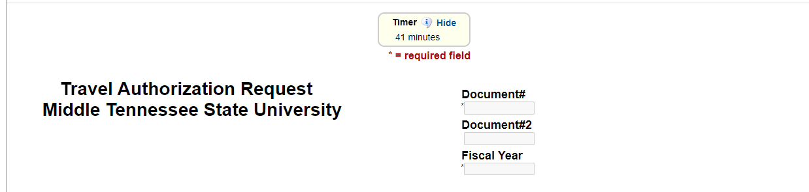

2. The next section requests the same as before on the paper form. Enter your Last Name, First Name, M#. You may enter a phone number if you wish but this is optional. This would be a way of contacting you if the Travel Office has questions about your travel.
You should read the printed information in this section. You may disregard the “Non-MTSU traveler” wording for now since you are an MTSU traveler.

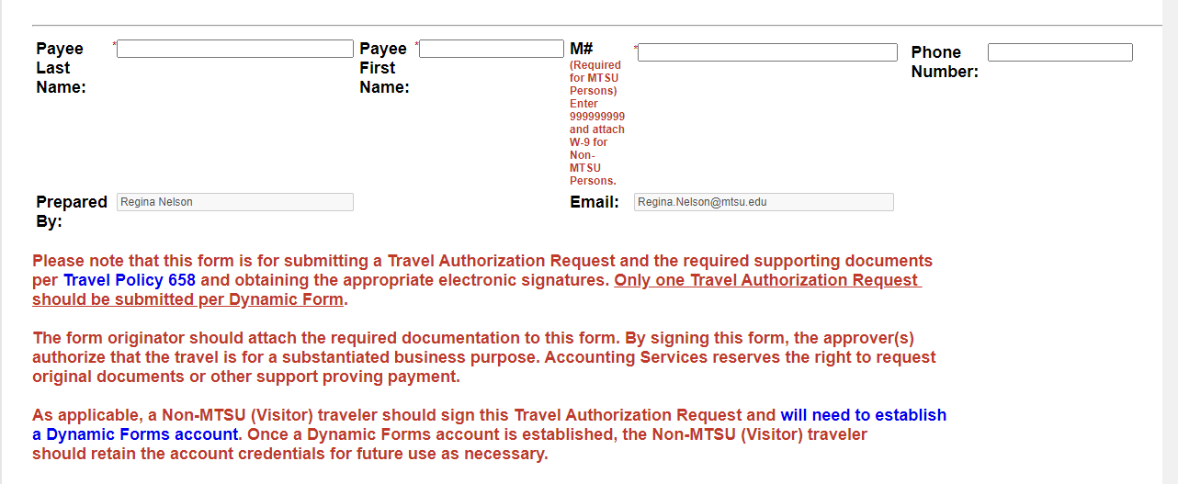

3. The next section is self-explanatory. You will most generally select: Initial Authorization. The Amended Authorization will not be used at this time. (It will only be selected when a TA number is assigned and there are changes that require an amended TA to the one already approved).
If you are not the Traveler (Payee) then you should not fill out this form and consult with Regina Nelson on the necessary steps.
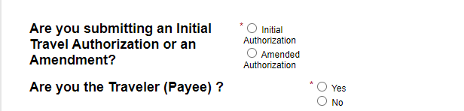

4. This section has been on the paper form but you may have not filled it out before. You will need to know who is paying for your travel. For most purposes, it will be only the English Department paying for your travel. Other Departments may also be funding your travel and, if so, you will list their names/emails.
If only English is funding your travel: You will select: “4” approvers and fill in the boxes with info below.
Regina Nelson regina.nelson@mtsu.edu
Stephen Severn stephen.severn@mtsu.edu
Heather Trimis heather.trimis@mtsu.edu
Meredith Dye Meredith.dye@mtsu.edu

If additional departments/grants are funding or partially funding your travel, you will need to add them as approvers. You will need to ask that department/grant who their approver/email is to be listed.
If you are doing International Travel, you will need to add three more approvers to your list.
Becky Cole becky.cole@mtsu.edu
Kimberly Edgar Kimberly.Edgar@mtsu.edu
Sidney McPhee Sidney.mcphee@mtsu.edu

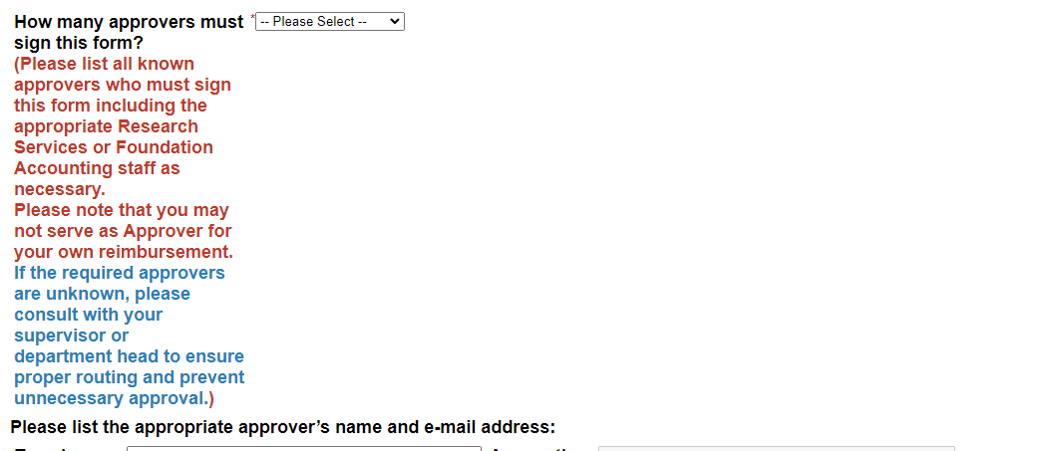

5. Enter your Travel Purpose and any Special Handling Instructions in the first box.
If you are doing International Travel, please make note in this box with explanation and reason. The Exception Memo will no longer be required since the approvers will include the appropriate names for International Travel.
Disregard the remaining boxes. (do not enter Accounting Services, Approver 1 Notes, etc.)
Make note to self: the Inititial Approver cannot edit the index or amounts but can only enter info in the Approver Box to be changed.
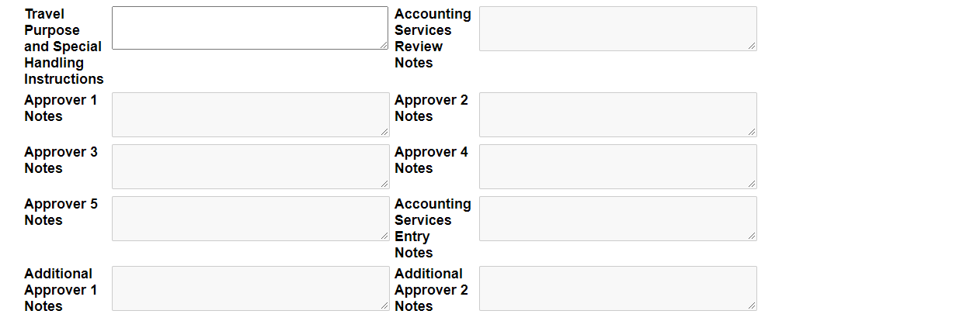

6. Supporting documents would be the same documents as you submitted with the paper forms. Instead of the paper copies, you will need to scan them. They will need to be scanned into one document and saved as a PDF. If you need help with this, please ask one of the secretaries. Once you have your scanned PDF, you will select “Choose File”, and select your saved copy.
Suggestions to include:
- Flyer or brochure of your conference and your presentation- only need the copy of the
title page showing conference, dates, place, copy of page showing your presentation, no
need to copy the entire brochure
- receipts for what you have paid for prior to traveling
- anything else you deem necessary
W-9 is not needed for full time faculty since you have one on file.

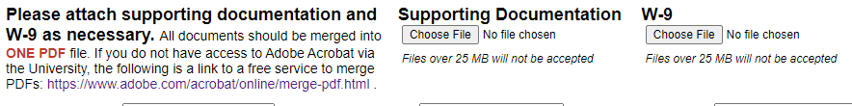

7. This section is self-explanatory.
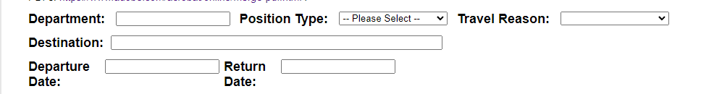
8. Estimation of Expenses. This asks for the same information as the paper form, but it is spread out more. Just take one line at a time and use the drop-down boxes. It is helpful to the Accounting Clerks if you would put your receipts in the same order as the expense blocks.
Registration Fee: Include receipts/estimations of expenses that you have incurred before travel.
Personal Transportation: (note: enter the number of miles, and the cost will auto calculate in the Reimbursable column)
Rental Transportation: Include receipts/estimations of expenses that you have incurred before travel.
Airfare: Include receipts/estimations of expenses that you have incurred before travel.
Lodging: Include receipts/estimations of expenses that you have incurred before travel.
Meals: (note: Travel Rate and Daily Rate will auto calculate when you fill in meal info).
For International Travel, please enter the current (October 2024) rate of $92 per day ($69 first/last day). Any meals that are part of the meeting agenda should be subtracted from the per diem.

Other Expenses: Any expenses that are not specific to the above boxes.

9. Enter the amount in the first box for the Amount Approved (If less than the total estimate of Travel Expenses):
The second box “Total Estimated Travel Expenses” is auto calculated from the info you put in.
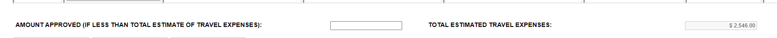

10. You will need to know the Index number, Account number and Amount for each funding source. For most faculty members since all funding comes from English, you will enter the English numbers:
Index Account Amount
213100 73210 (out of state travel)
or
213100 73250 (out of country travel)

If Regina has used the English Pcard for you, enter Regina Nelson.
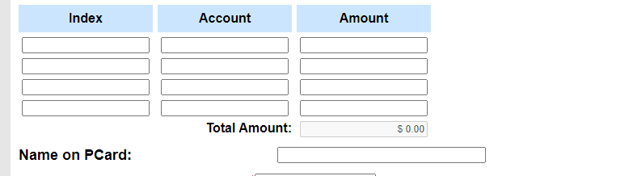
The “Total Amount” should be the same as the above “Amount Approved…”

11. This is usually not filled out. If you do wish to receive a completed copy (includes all approver signatures), please enter your information here. Reminder, you can at any time go into the system and open and print your document.
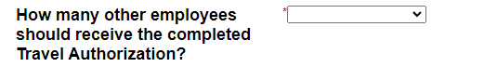

12. Use this section only if you are getting an Advance for International or Group Travel.
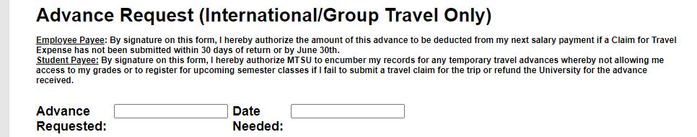

13. Accounting Services Review section. Leave all of this blank.

14. Click “Save Progress” button. You can save this form at any time and come back to it later. See below for retrieving
your saved form.

Or

Click “Next” button. Hit this when you are done and ready to sign, electronically. Once you have submitted this electronically, it will go to the next approvers. Once all have approved, you should receive an email with your TA number.

You can print the pdf. After you submit, you will see a button that says View PDF. Click this to open it. You can click the Print button. Save the completed PDF by clicking the Save icon.

TO RETRIEVE YOUR SAVED TRAVEL AUTHORIZATION FORM:
Best way is through Pipeline/Employee Resources/Dynamic Forms.
A list should come up “Pending/Draft Forms”. You should see yours under “Travel Authorization Request”.
Go to the far right under the Action column and select the Action drop down box.
Select Complete Form. You may continue your form.

TO CHECK STATUS ON YOUR TRAVEL AUTHORIZATION FORM:
Best way is through Pipeline/Employee Resources/Dynamic Forms.

A list should come up “Pending/Draft Forms”. You should see yours under Form Name “Travel Authorization Request”.
Go to the far right under the Action column and select the “View PDF” drop down box. Scroll down to see who the last signature was and when it was signed. This will let you know who to call for the next signature.

